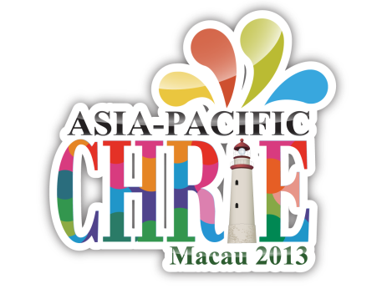
ASIA-PACIFIC CHRIE Macau 2013
For Official Use Only
Ref NO:
www.umac.mo/fba/apacchrie2013/
STEP 1: PERSONAL INFORMATION
Title: Prof./Dr./Mr. / Mrs. / Ms.
First Name: |  |  | Last Name:
School/ Organization:
Position:
Mailing Address:
City: | Country: |  |  |  | Postal code:
*Phone: ( ) |  | *Fax: ( )
*Email:
STEP 2: ITINERARY AND ROOM RESERVATION
Arrival(MM/DD/YY):  Estimated Check-in Time: |  |  |  | Departure(MM/DD/YY):
ROOM RATE per room per night 20- 23 May, 2013 (Monday – Thursday)
* Please mark x which you prefer.
* The hotel prices are subject to change.
□ Deluxe Room King (room only) MOP1,500++
□ Deluxe Room King (with 1 daily breakfast) MOP1,708++
□ Deluxe Room King (with 2 daily breakfasts) MOP1,916++
□ Additional: Executive Club Privileges(_____days ______pax) (MOP500++/day/pax, MOP700++/day/pax)
STEP 3: PAYMENT METHODS
Credit Card
□ Master OR □ Visa
Name on the card: _____________________________
Credit Number: _______________________________ CID (last 3 digits at the back): __________________________
Expiry date: __________________________________
Signature: ____________________________________
Room Reservation Form
Kindly send your completed reservation form to (e-mail & fax are preferable):
* Please also note that your room will only be confirmed after you received another email with title "Hotel Room Reservation Confirmation".
Address: University of Macau, Faculty of Business Administration, Hospitality and Gaming Program, Av. Padre Tomas Pereira, Taipa, Macau ChinaTel: 853-8397 4731 or 853-8397 4799 Fax: 853-2883 8320 Email: apacchrie@umac.mo

